**Subject: Fundamentals of Software Engineering**

**Project: Crime Investigation System**

**Group members:**

**Fatima Riaz (23L-2637)**

**Mahnoor Naveed (23L-2516)**

**Rabia Saeed (23L-2560)**

**Aliza Sharafat (23L-2524)**

**Deliverable # 4**

**Date of Submission: May 4,2025**

**Project Introduction:**

**Project Title:** Crime Investigation System

**Introduction:**

The Crime Reporting and Management System is a WinForm application designed to facilitate crime reporting, case management, and law enforcement operations. The system enables different users, including public users, officers, and authorities, to interact efficiently for crime tracking and resolution. The application ensures secure authentication, structured reporting, and case handling for better crime management.

**User Stories**

**1. Store Reported Cases**  
As an admin, I want to store reported cases so that I can maintain records.

**2. User Registration and Login**

As a user, I want to register and log in so that I can access my account.

**3. Edit Profile Information**  
As a user, I want to edit my profile so that I can update my details.

**4. User Dashboard Access**  
As a user, I want a dashboard so that I can view relevant data.

**5. Public Crime Report Submission**  
As a public user, I want to submit a crime report so that I can report an incident.

**6. Review Submitted Reports**  
As an officer, I want to review reports so that I can approve, reject, or mark them for review.

**7. File an FIR**  
As an officer, I want to file an FIR so that I can officially register a case.

**8. Assign Cases to Officers**  
As an authority, I want to assign cases so that I can distribute workload efficiently

**9. Update Case Progress**  
As an officer, I want to update case progress so that I can track investigations.

**10. Review Submitted Leads**  
As an officer, I want to review leads so that I can verify useful information.

**11. Manage Evidence**  
As an officer, I want to manage evidence so that I can validate and store case data.

**12. Public Lead Submission**  
As a public user, I want to submit leads so that I can assist investigations.

**13. Public Evidence Submission**  
As a public user, I want to submit evidence so that I can support cases.

**14. Detect Late Reports**  
As an officer, I want to detect late reports so that I can track delays.

**15. Detect Similar Cases**  
As an officer, I want to detect similar cases so that I can find patterns.

**16. Analyze Crime Waves**  
As an officer, I want to analyze crime waves so that I can take immediate action.

**17. Identify Fake Reports**  
As an officer, I want to identify fake reports so that I can filter false data.

**18. Visualize Crime Trends**  
As an officer, I want to visualize crime trends so that I can analyze crime situations.

**19. Validate Testimonies**  
As an officer, I want to validate testimonies so that I can detect inconsistencies.

**20. Detect Late Reports**  
As an officer, I want to detect late reports so that I can track delays.

**21. Match Missing Persons**  
As an officer, I want to match missing persons so that I can find possible matches.

**22. View High-Risk Areas**  
As an officer and public, I want to view high-risk areas so that I can be alert.

**Design:**

**Use Case Diagram:**

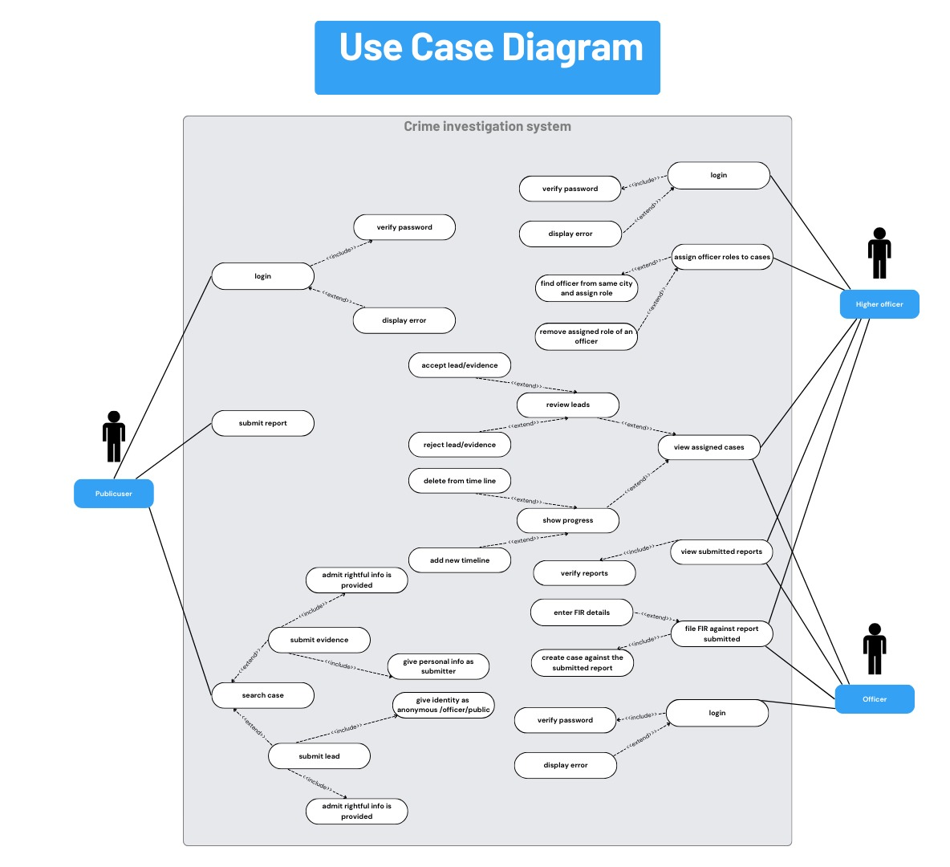

**Class Diagram:**

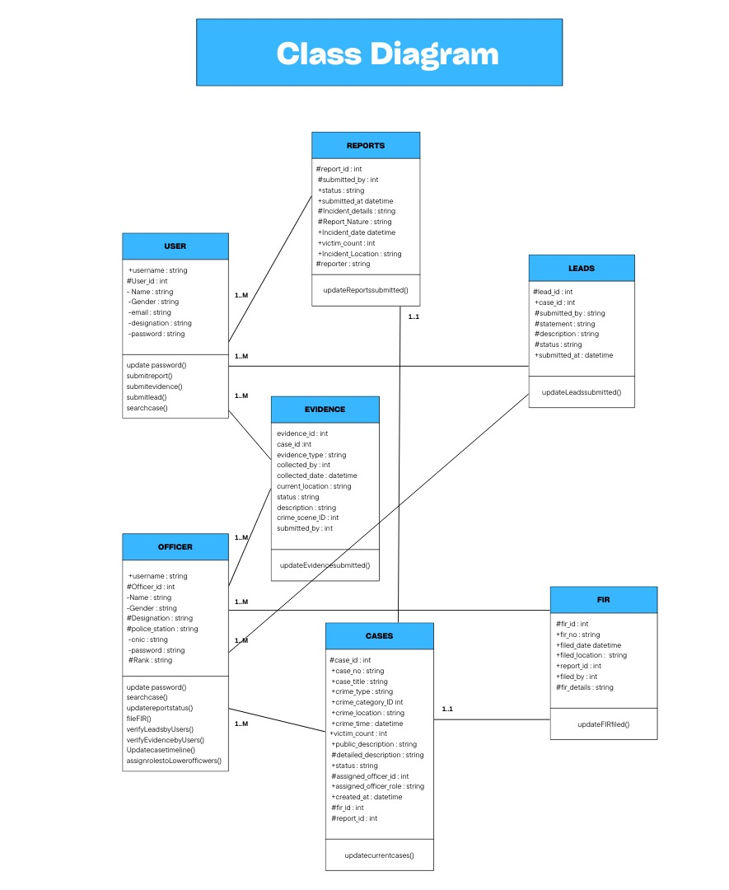

**Activity Diagram:  
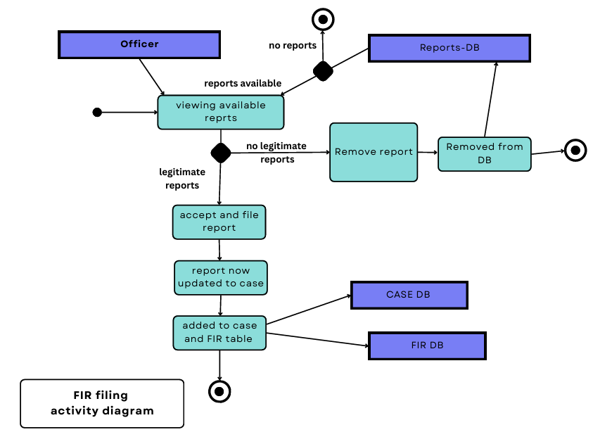**

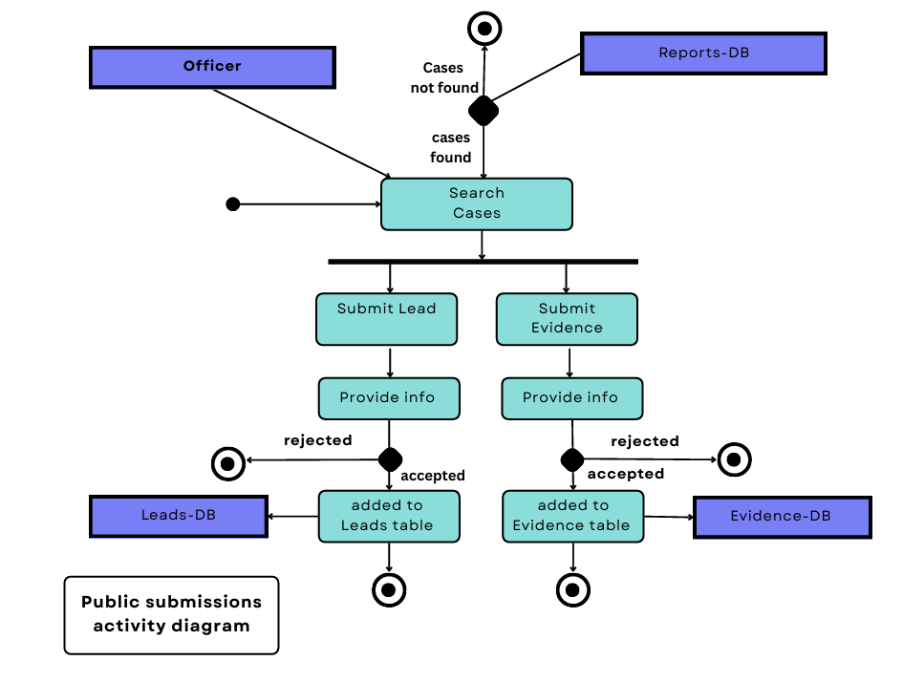

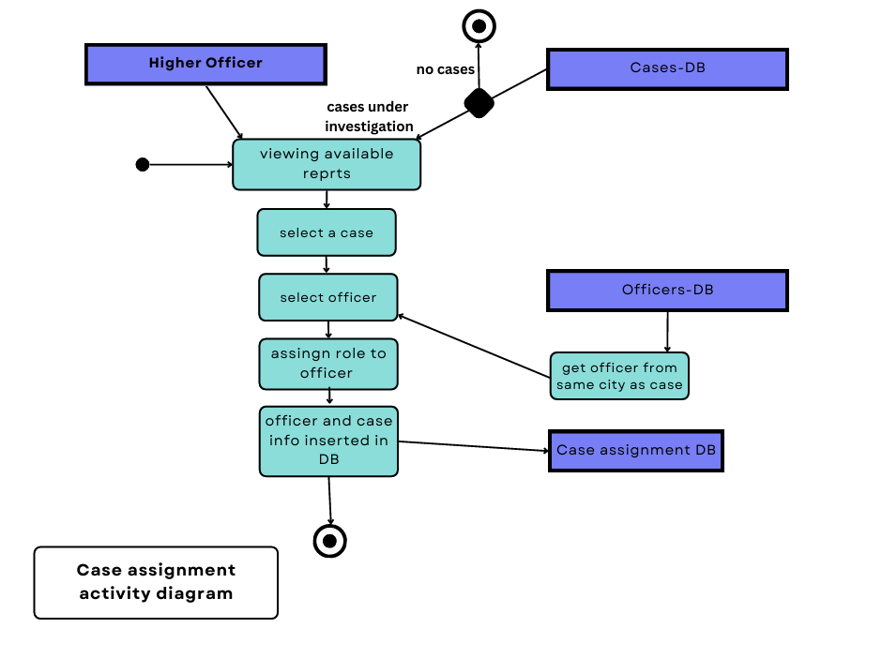

**Sequence Diagram:**

File FIR

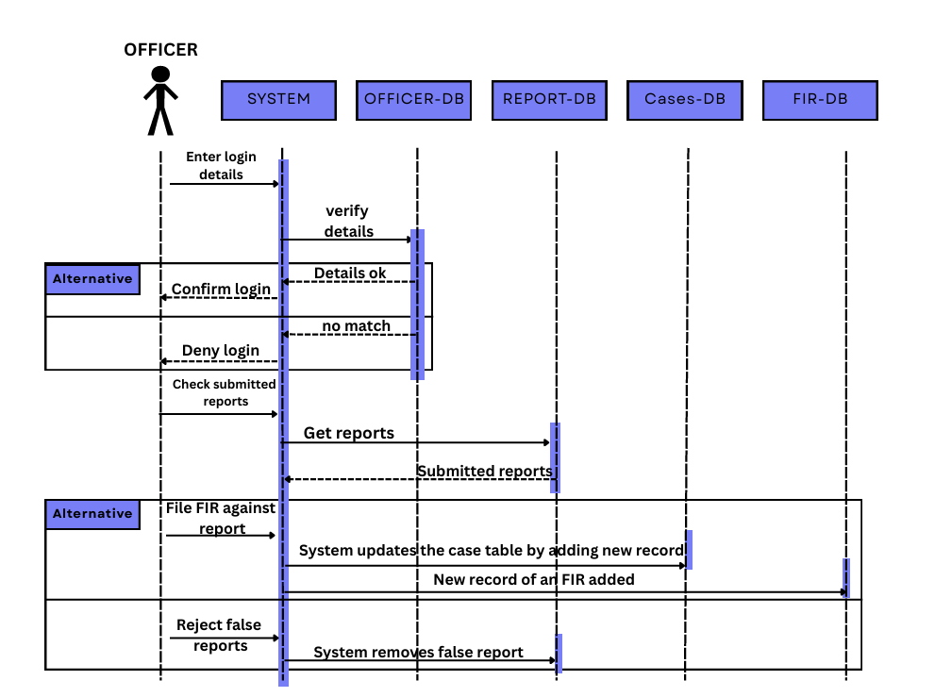

Submit Evidence:

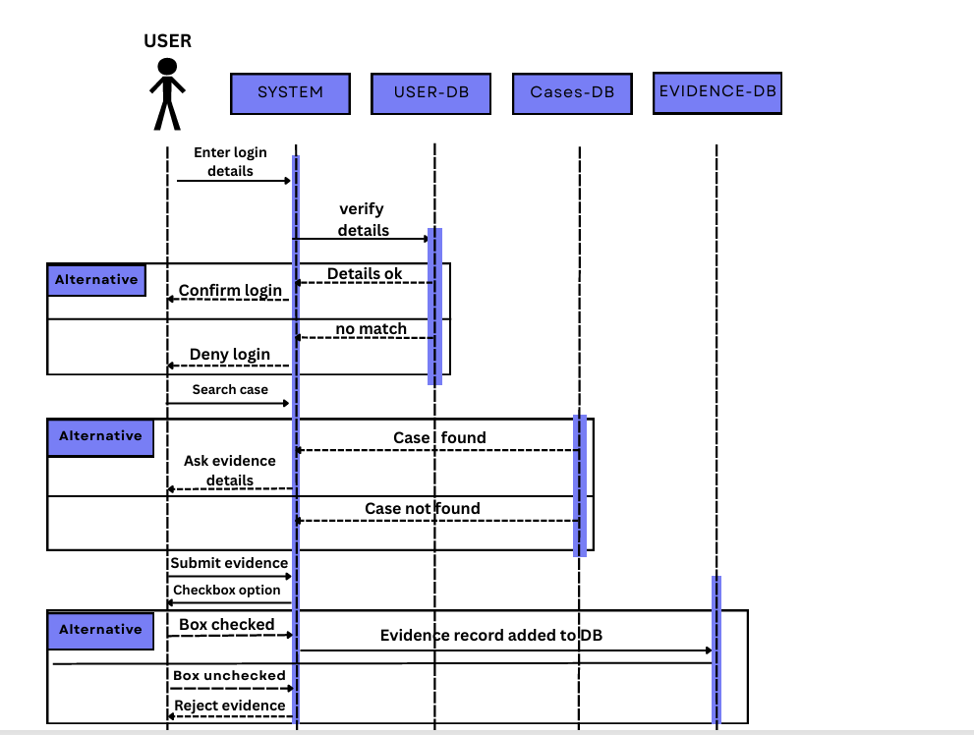

Submit Lead:

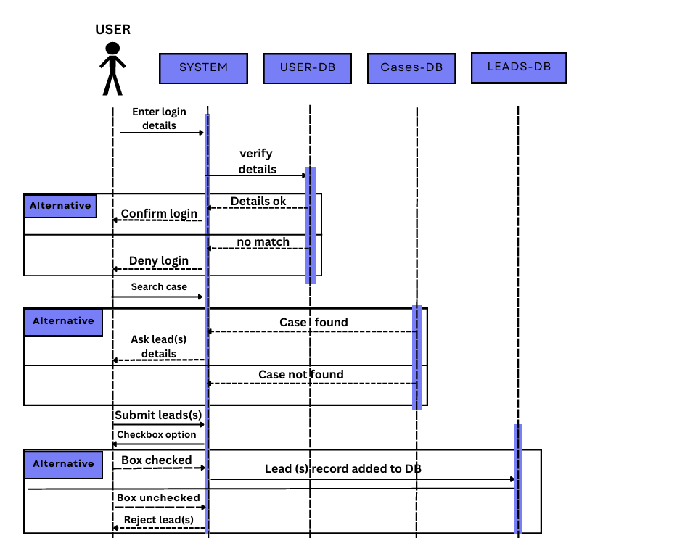

**Architecture:**

**Implementation Screenshots:**

Login:

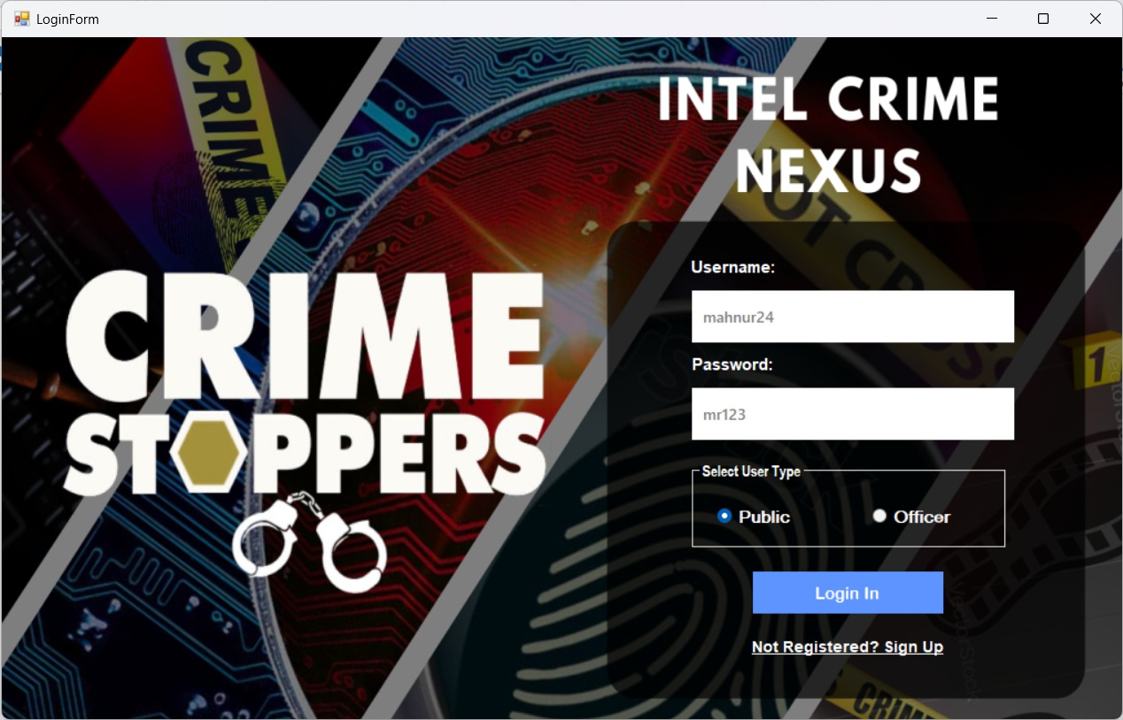

Sign up:

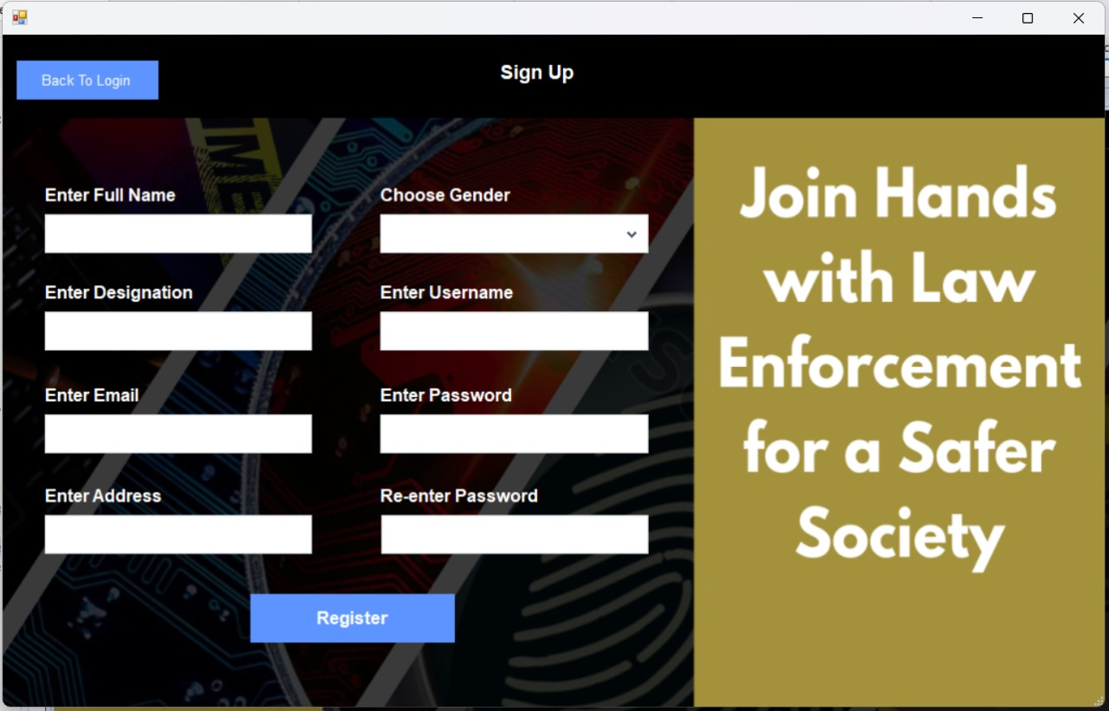

Public Dashboard:

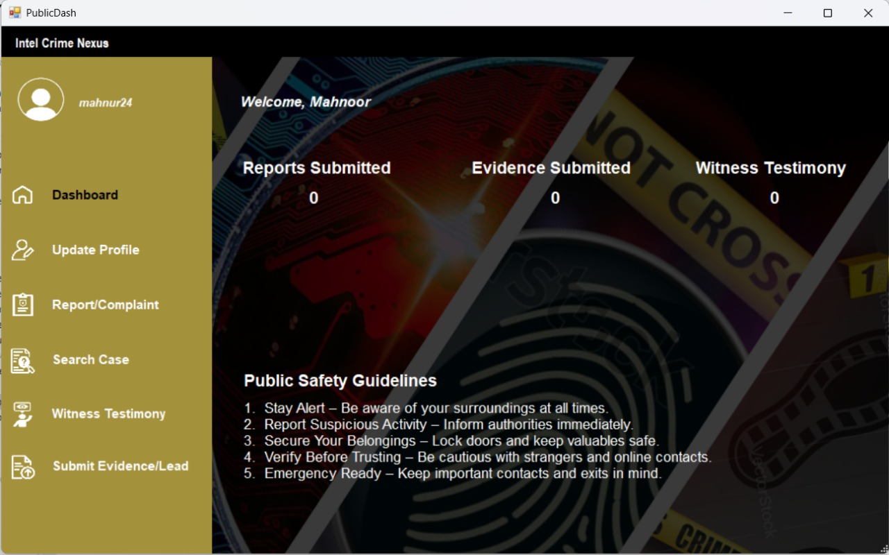

Update Public Profile:

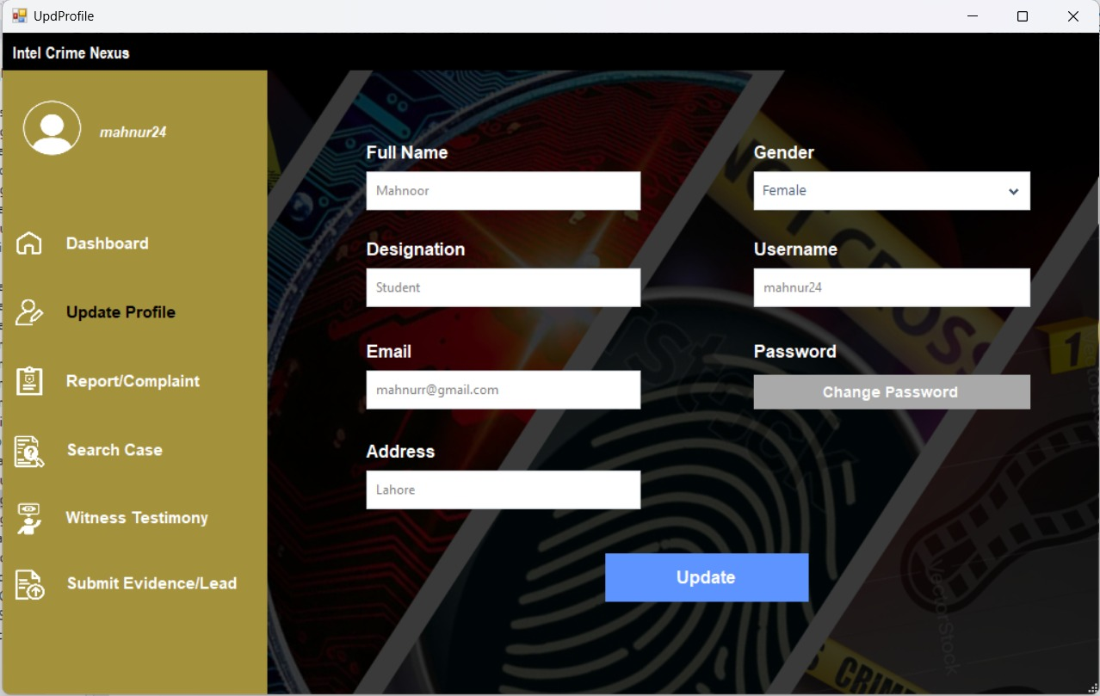

Change Password in Public Dashboard:

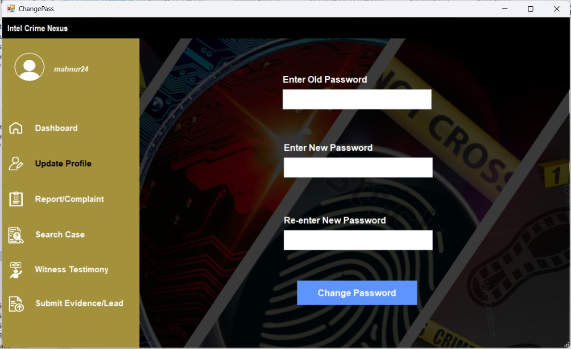

Search Case In Public Dashboard:

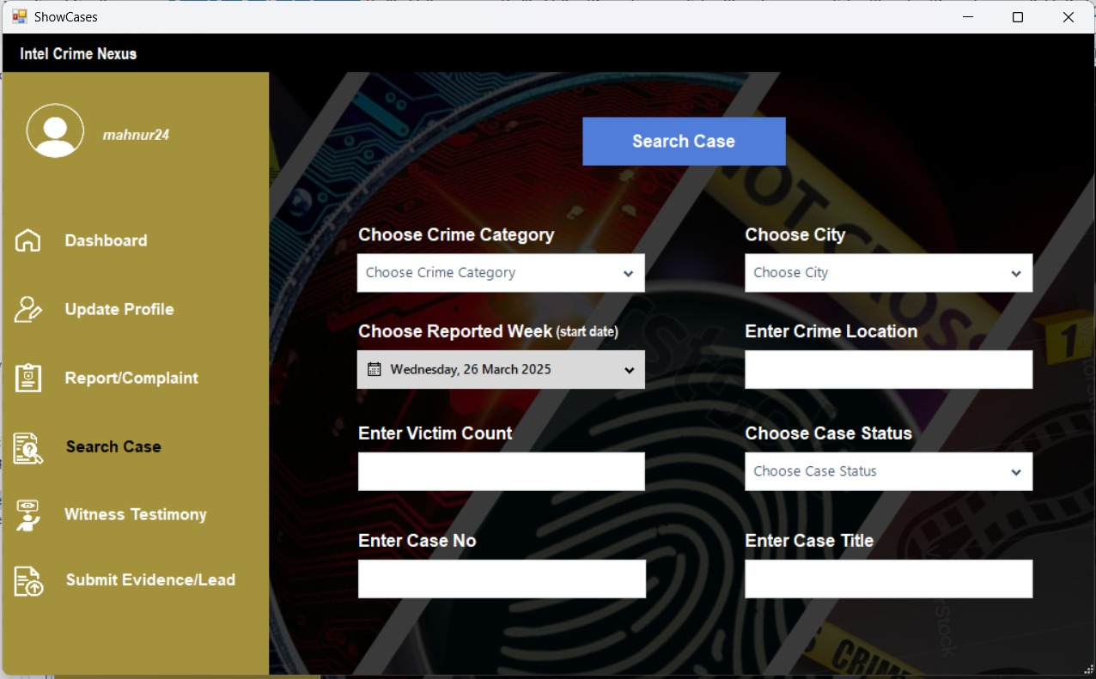

Submit Complaint:

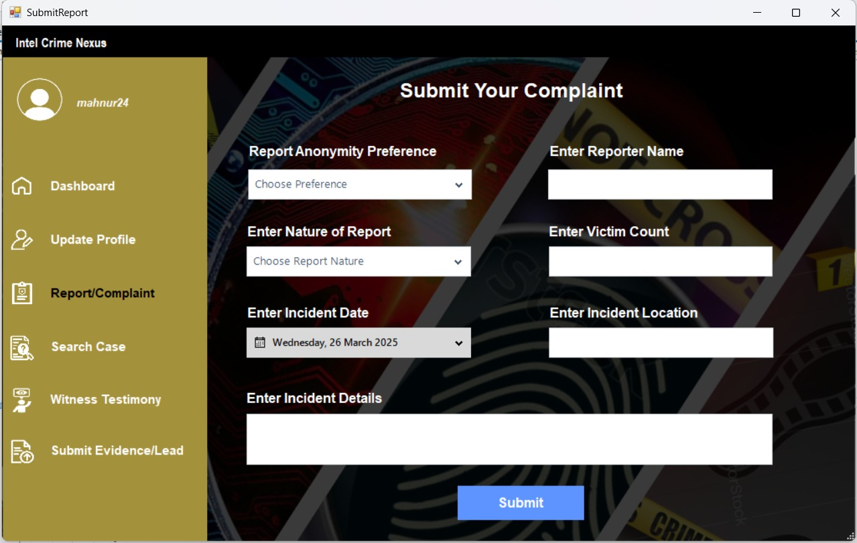

Officer dashboard:

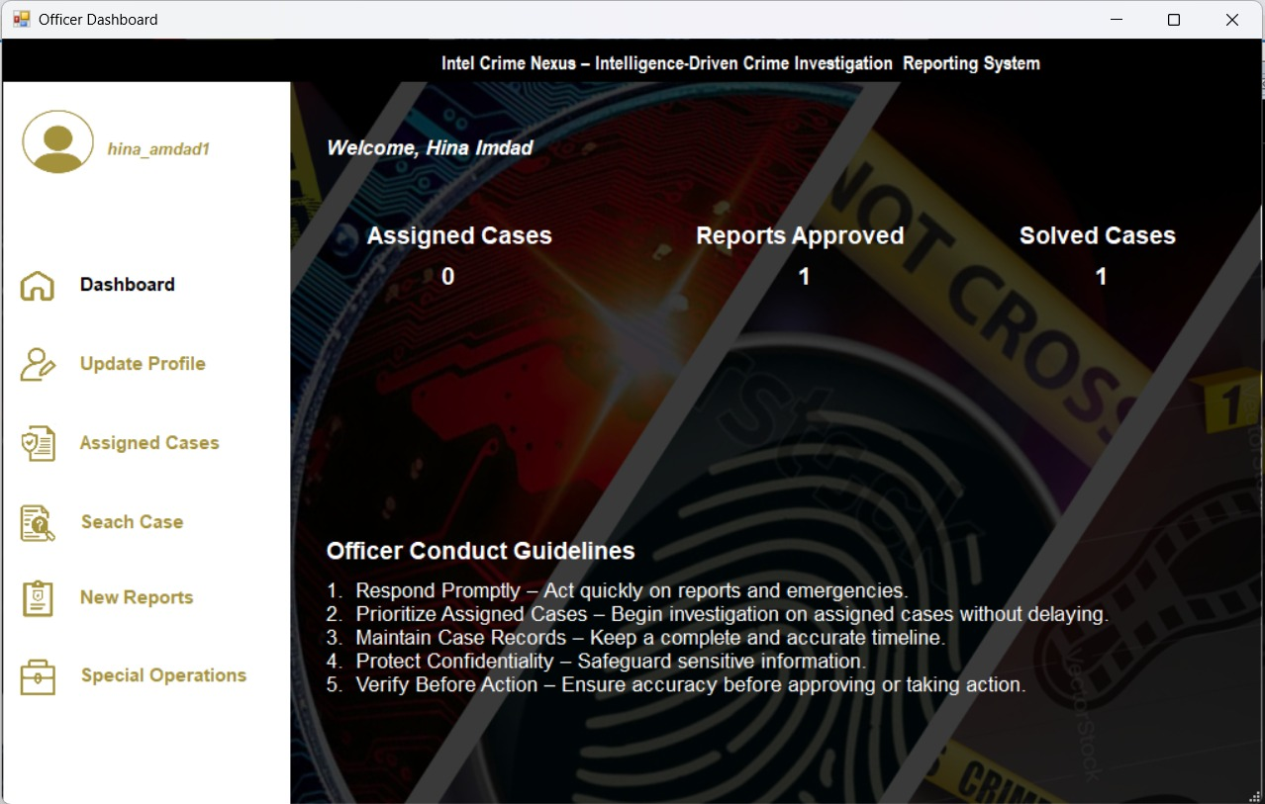

Update Profile of Officer: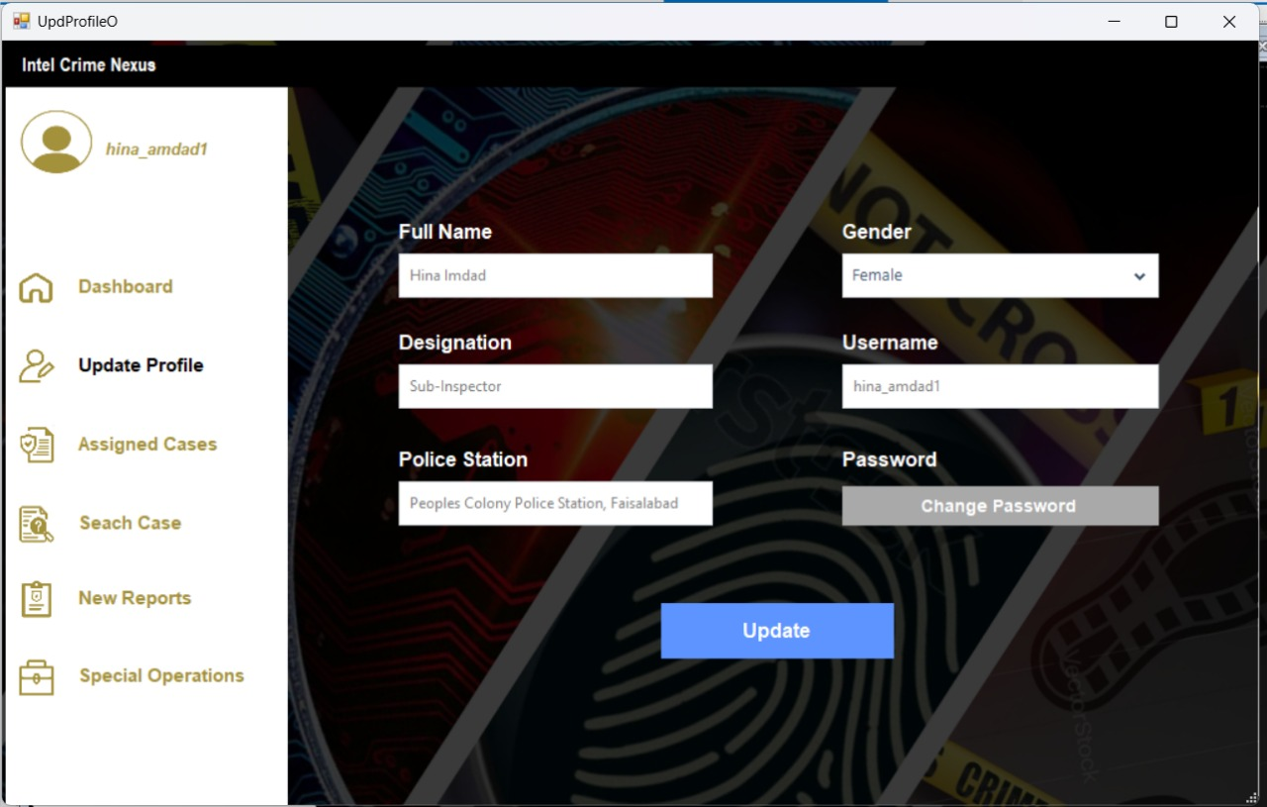

Search cases from Officer Dashboard: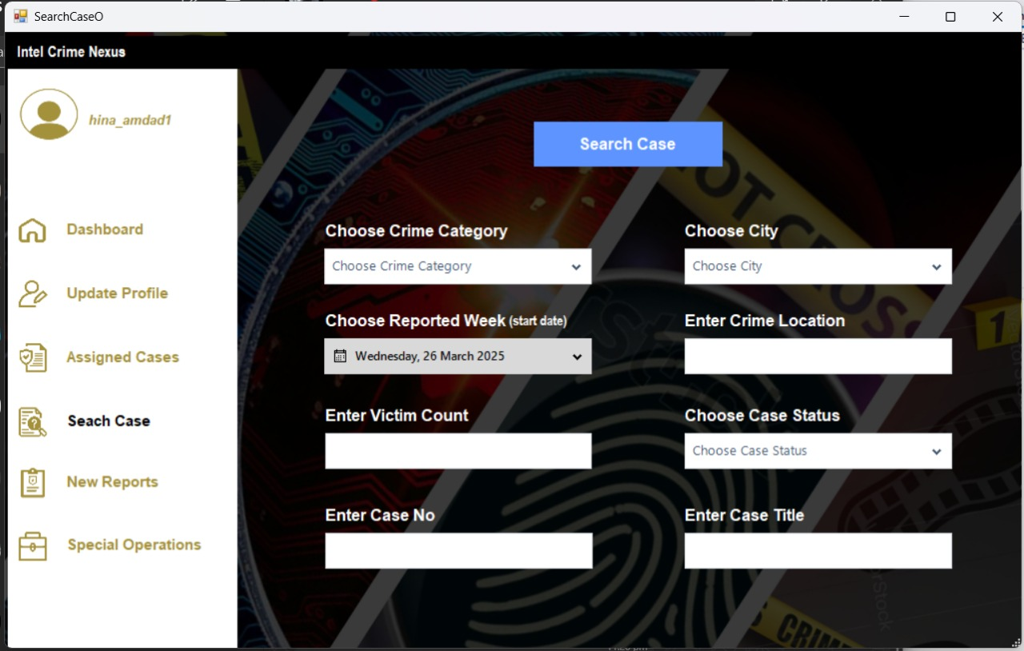

Search new Reports from Officer Dashboard:

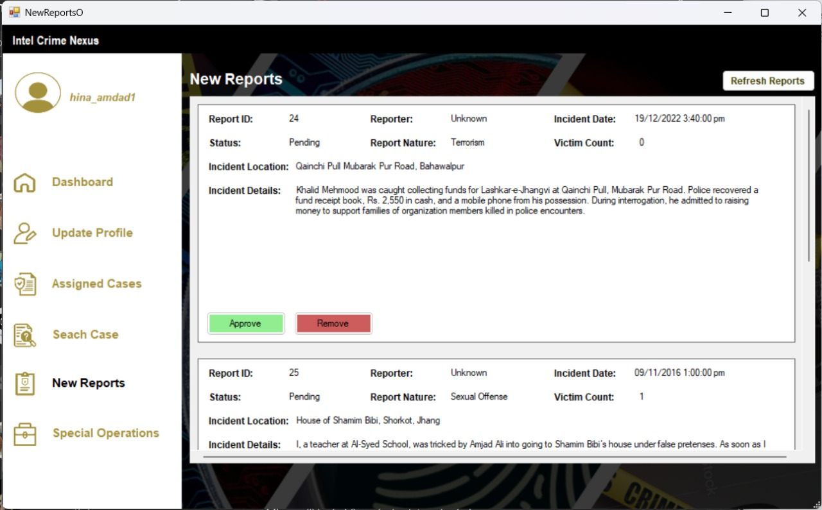

Select Report to file an FIR:

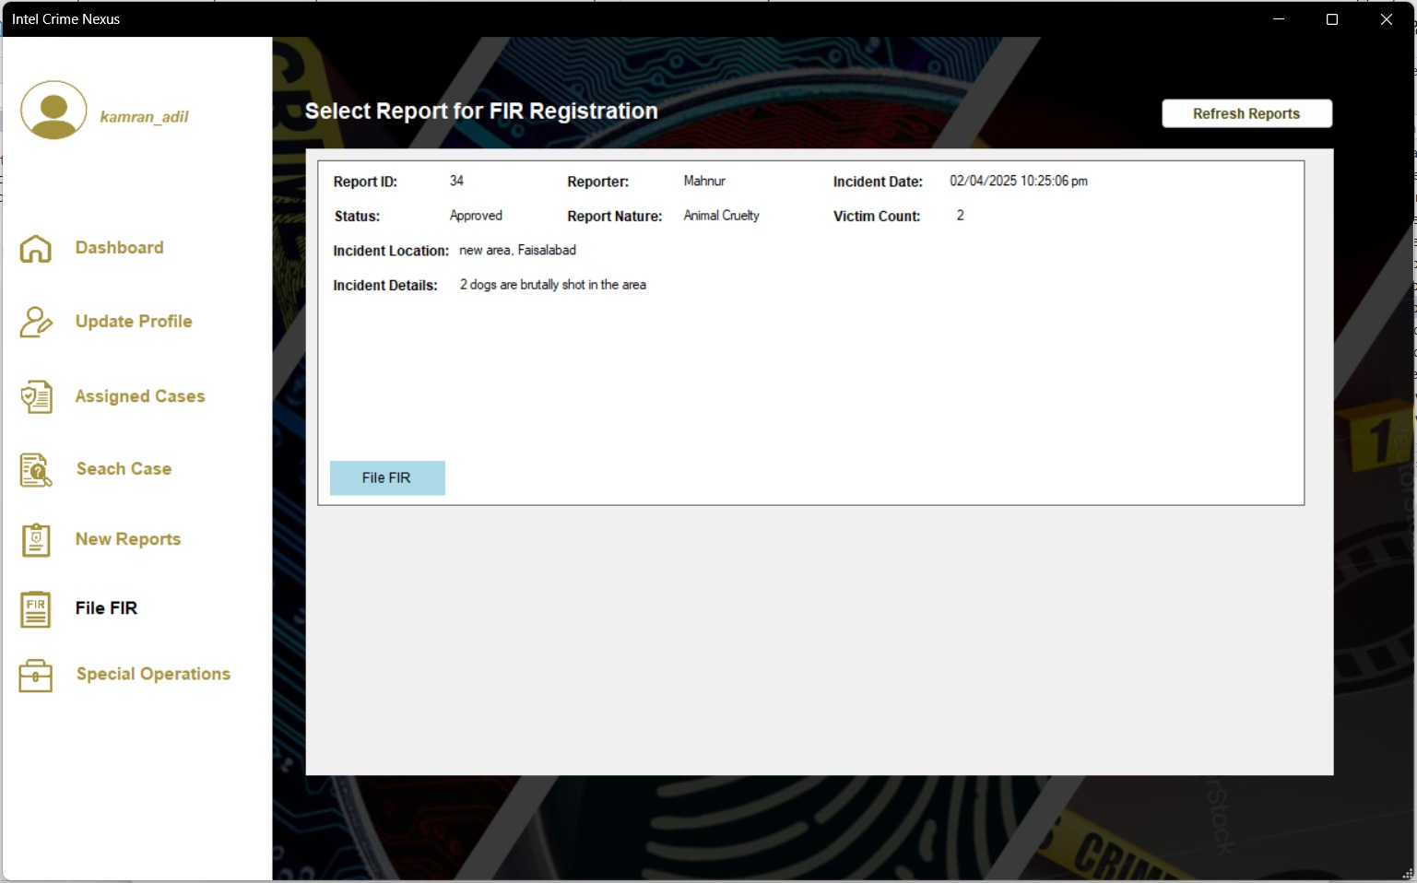

File an FIR:

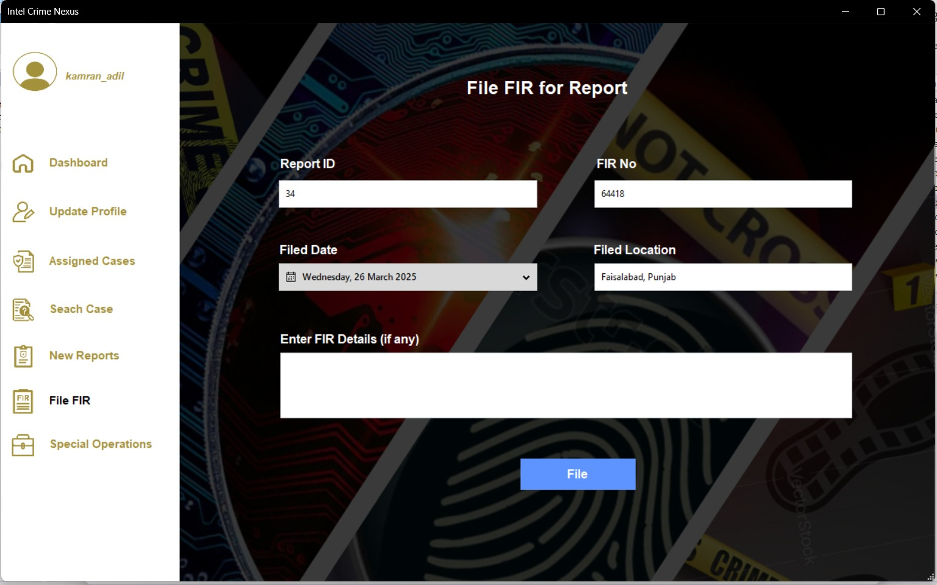

Special Operations of Higher Officer:

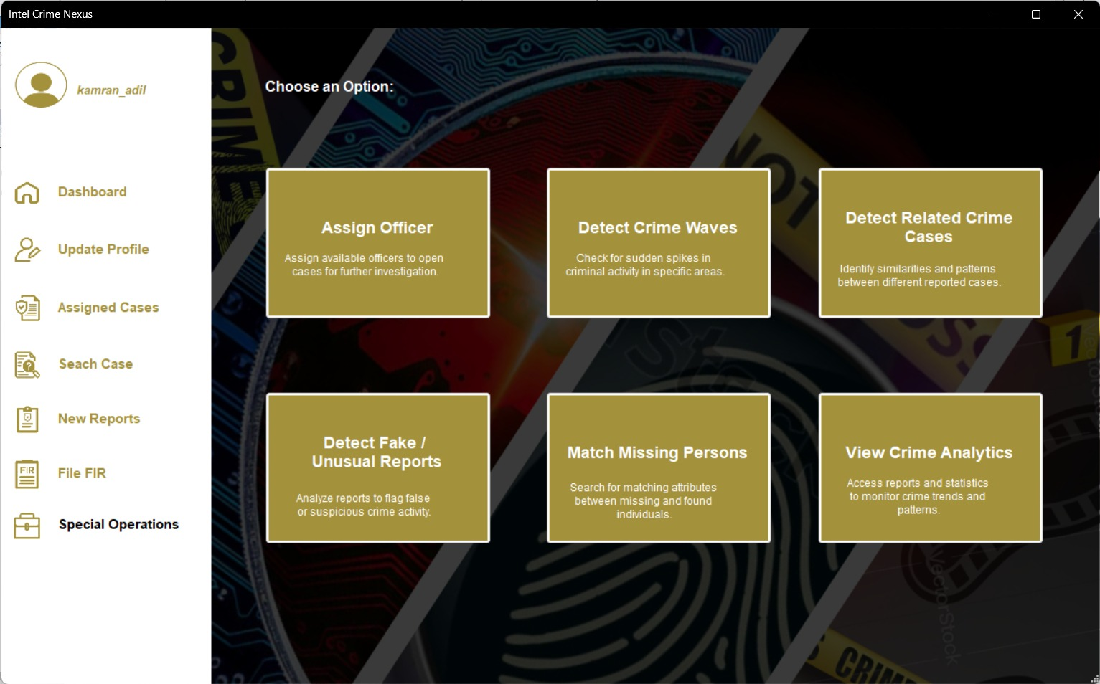

Assign Officer in Special Operations:

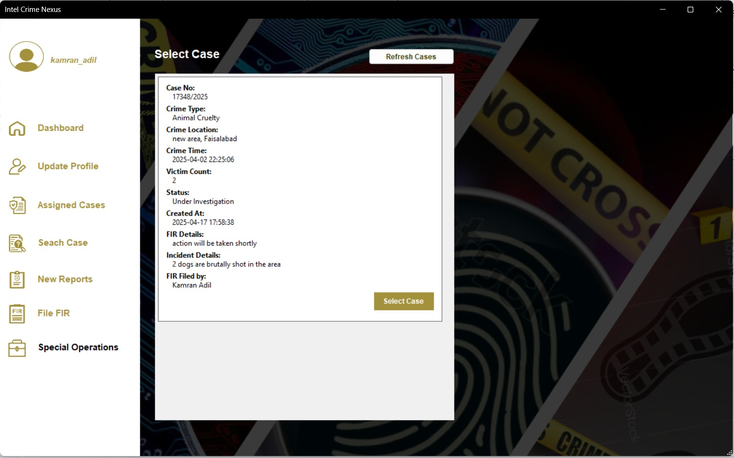

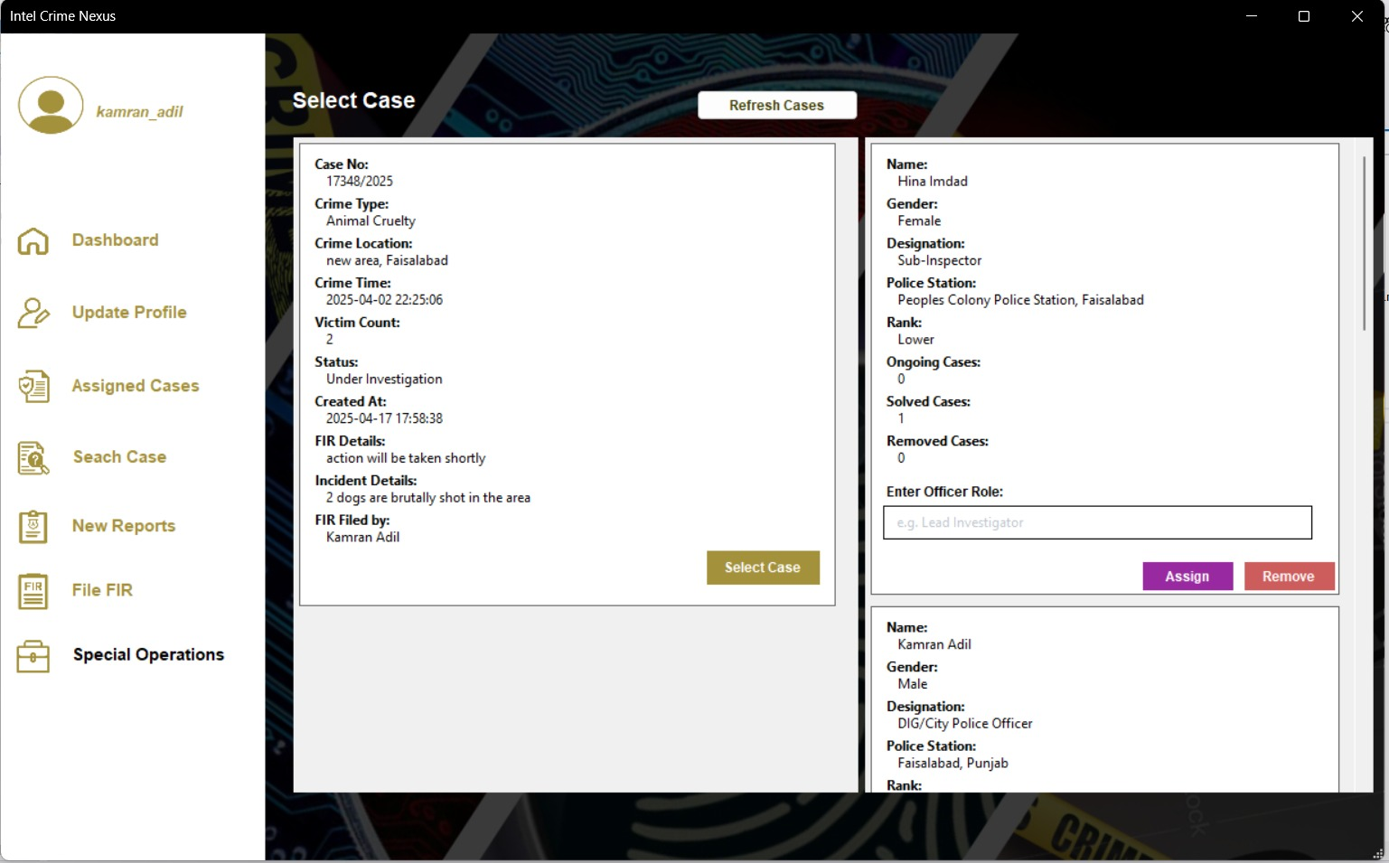

Officer can see Assigned Cases in his/her profile:

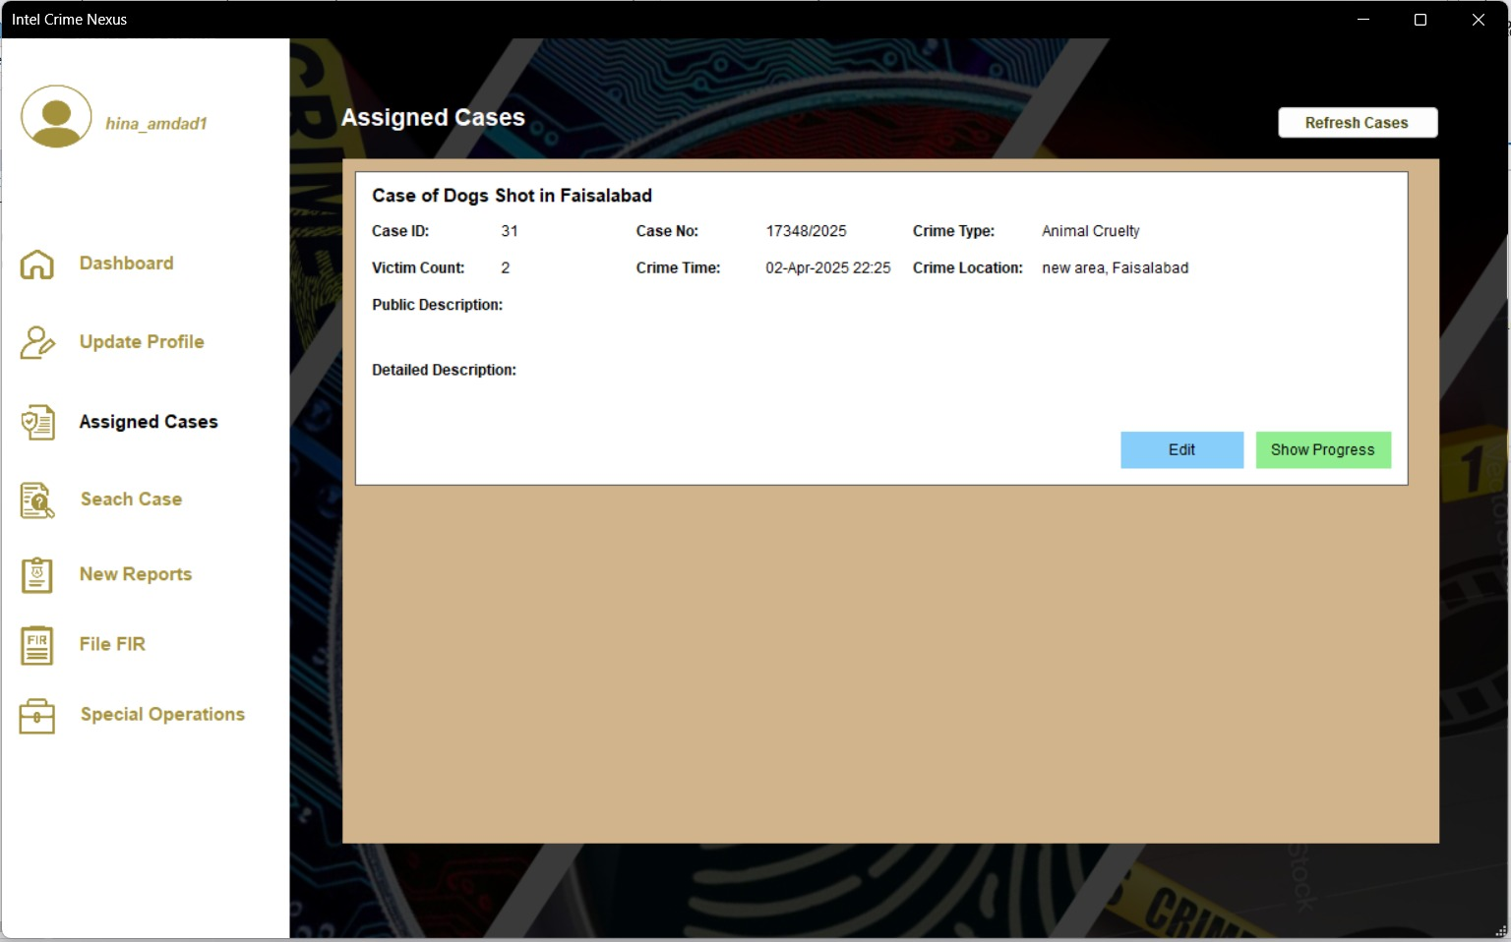

Case Related Operations (See Progress):

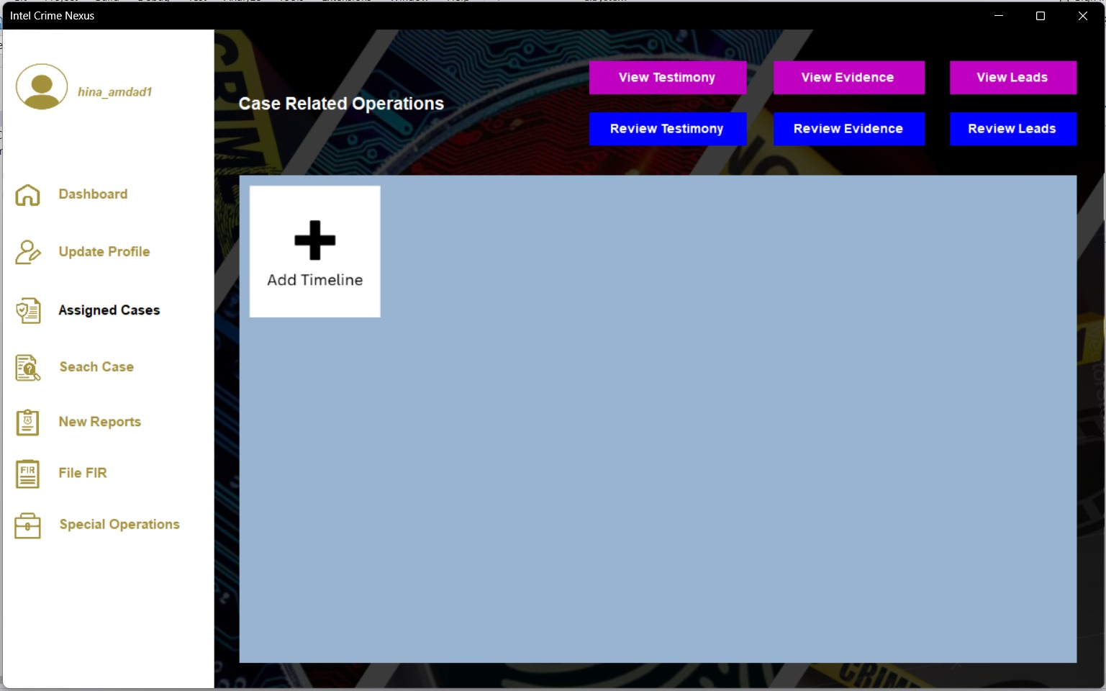

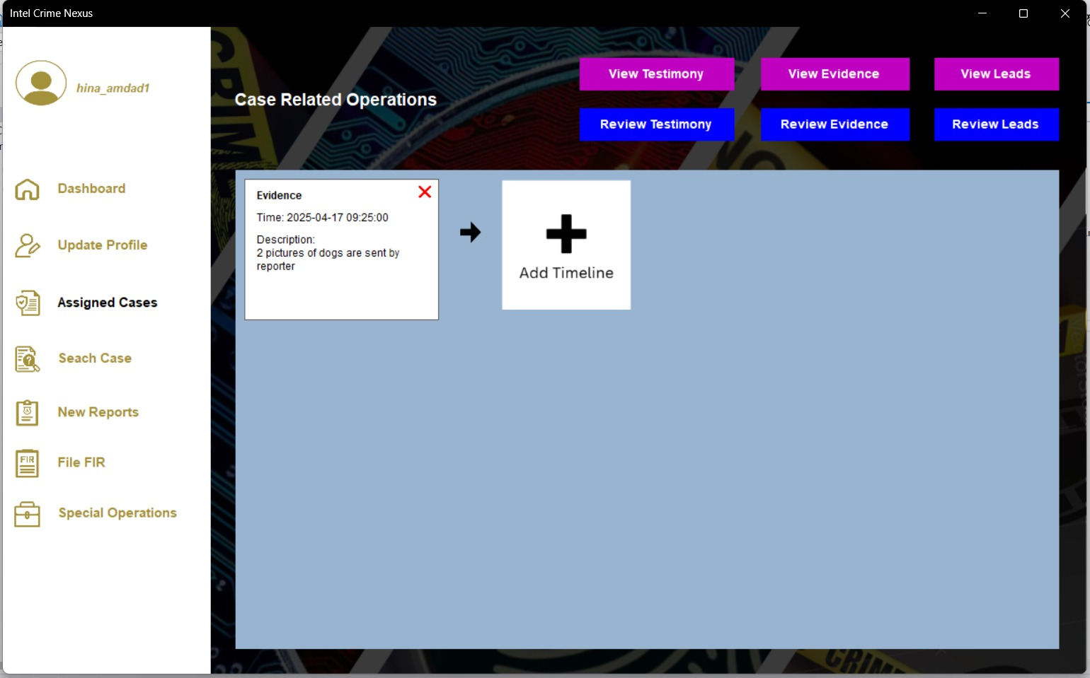

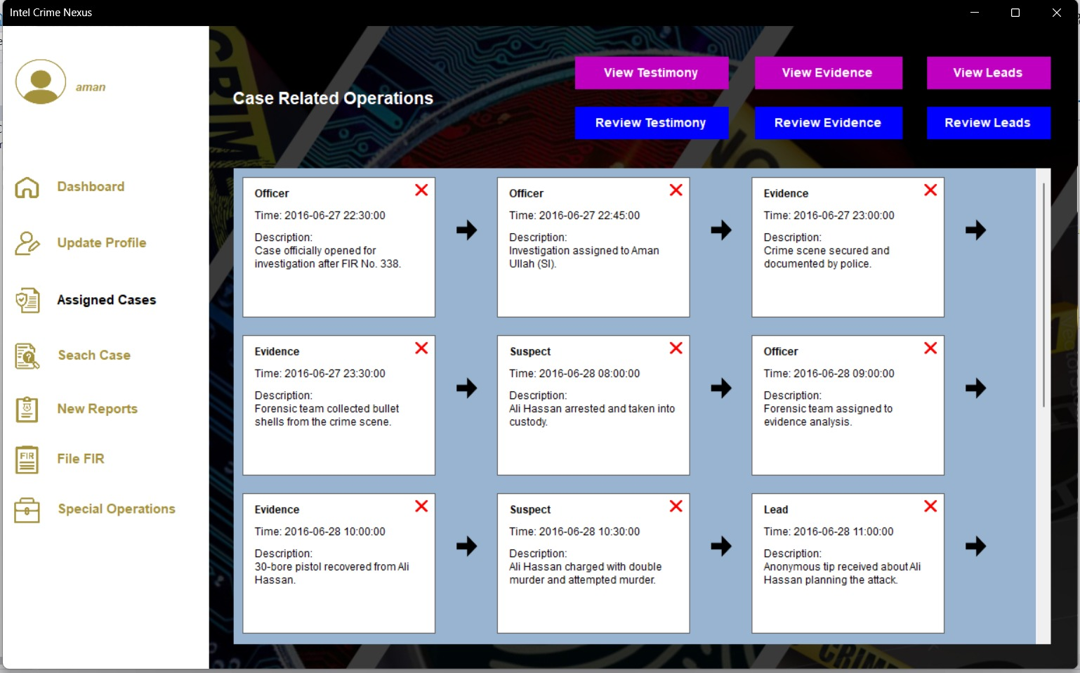

Review Leads:

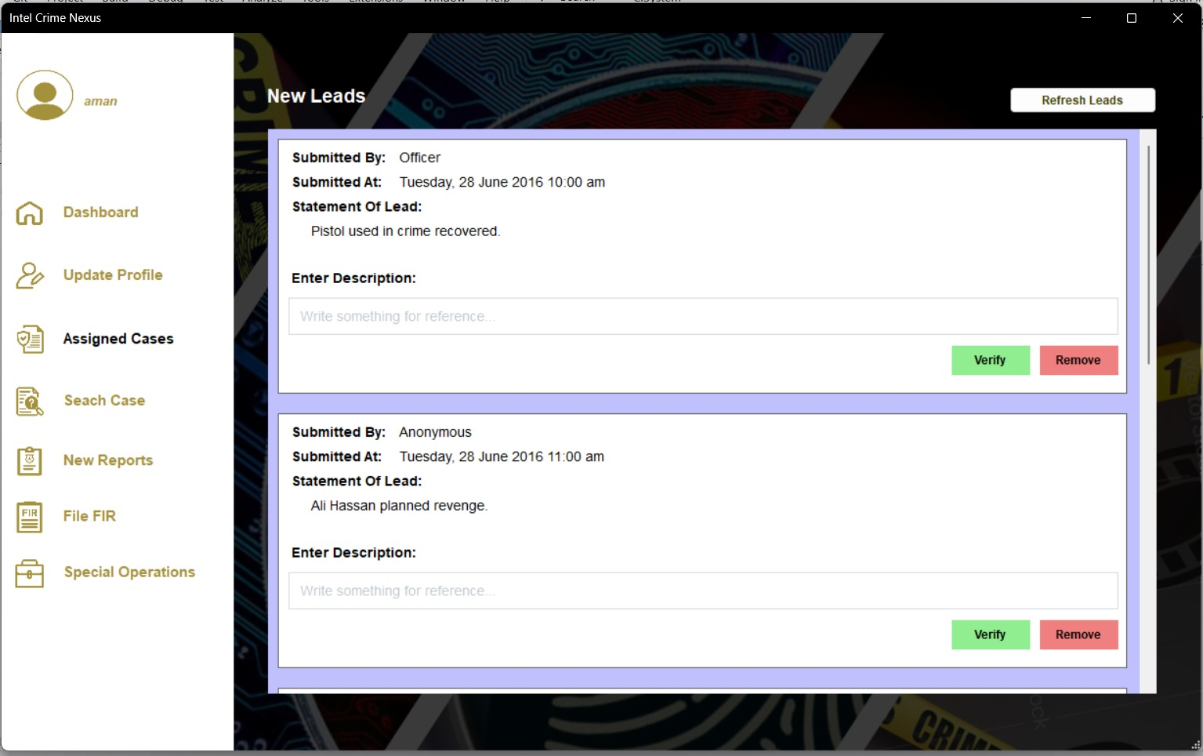

Review Evidence:

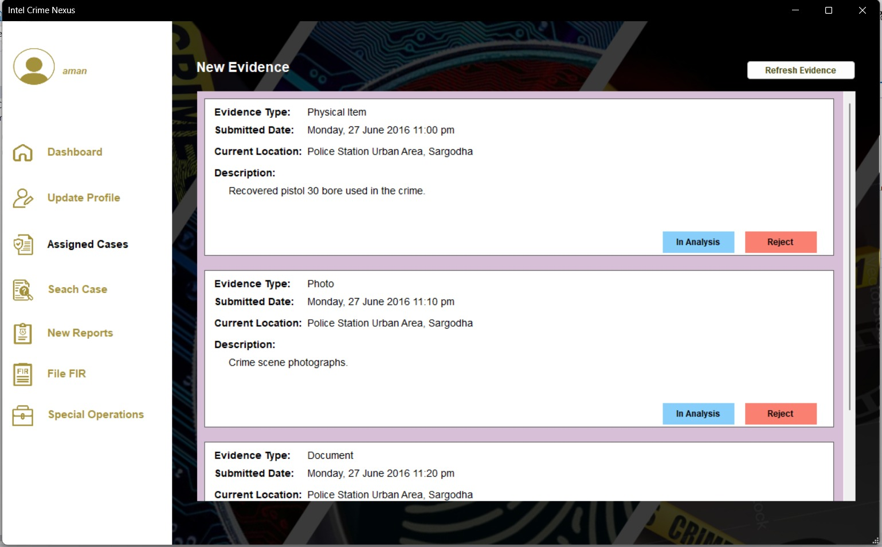

Add Timeline of Case:

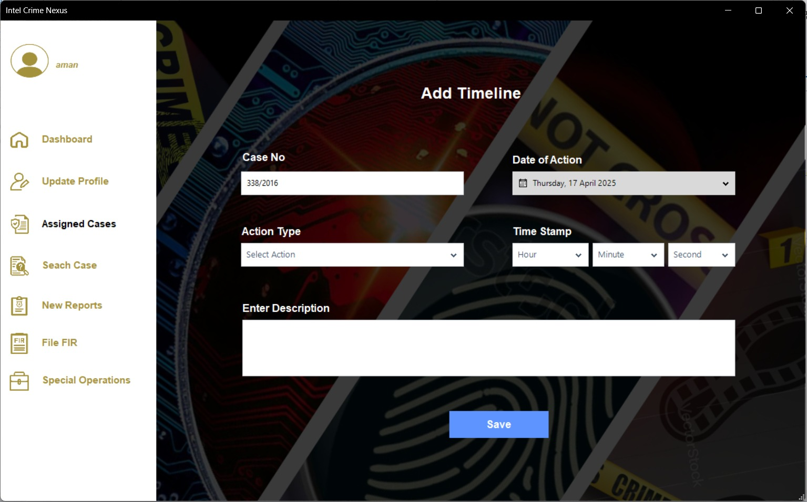

Case Search in Which User has to Submit Evidence or Leads:

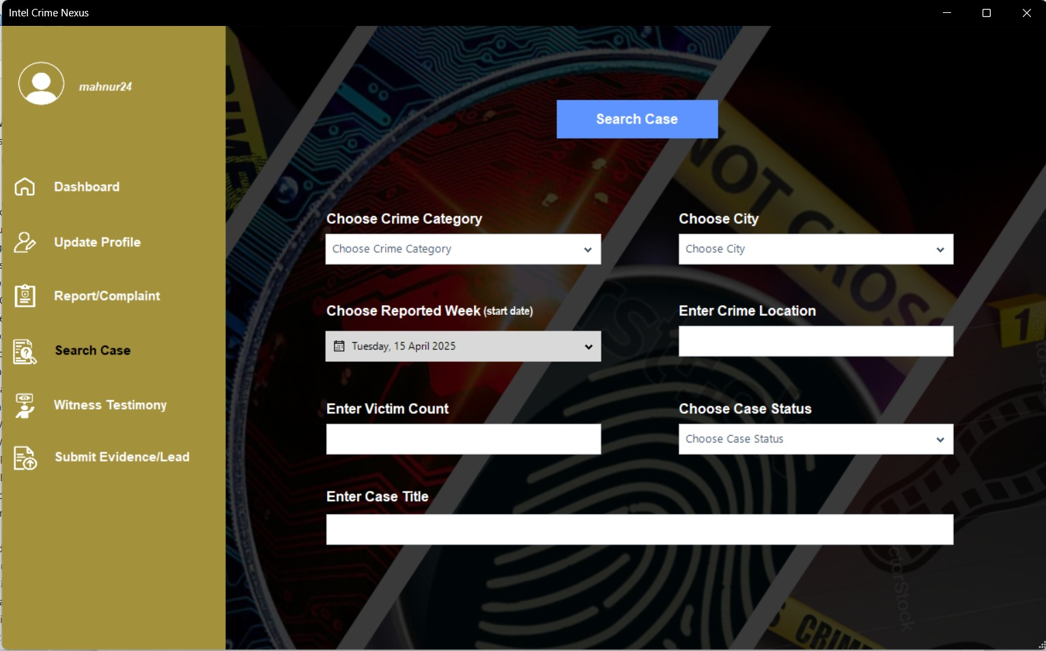

Opened Desired Cases Filtered by User:

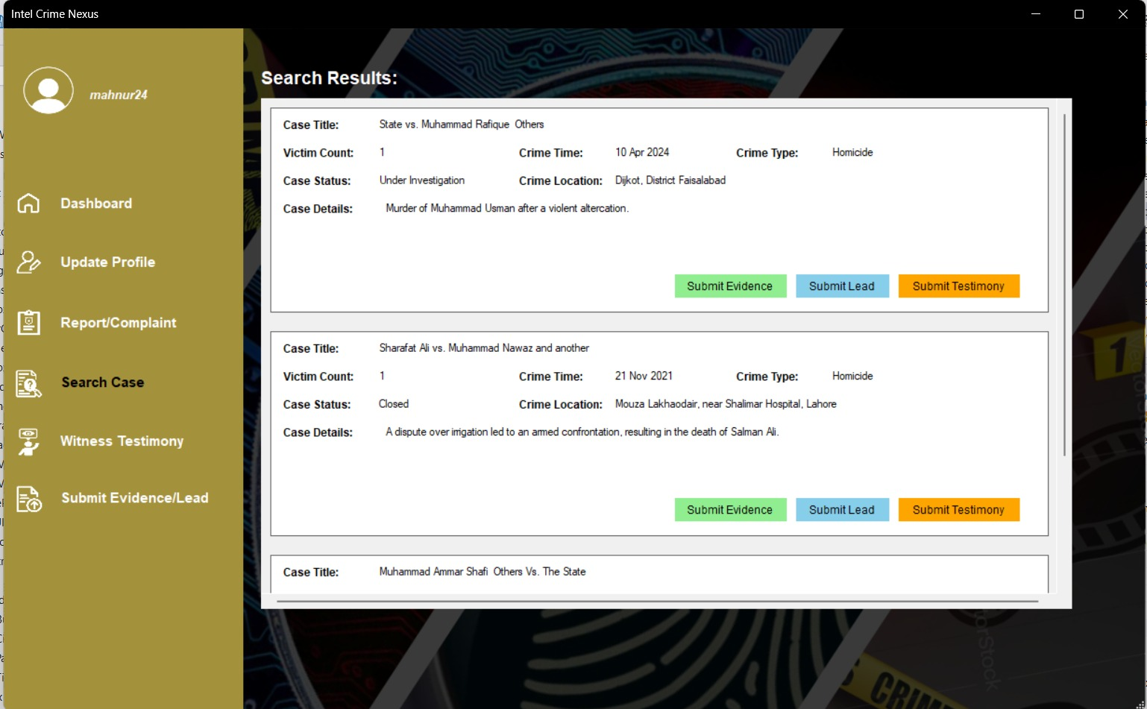

Submit Lead by User:

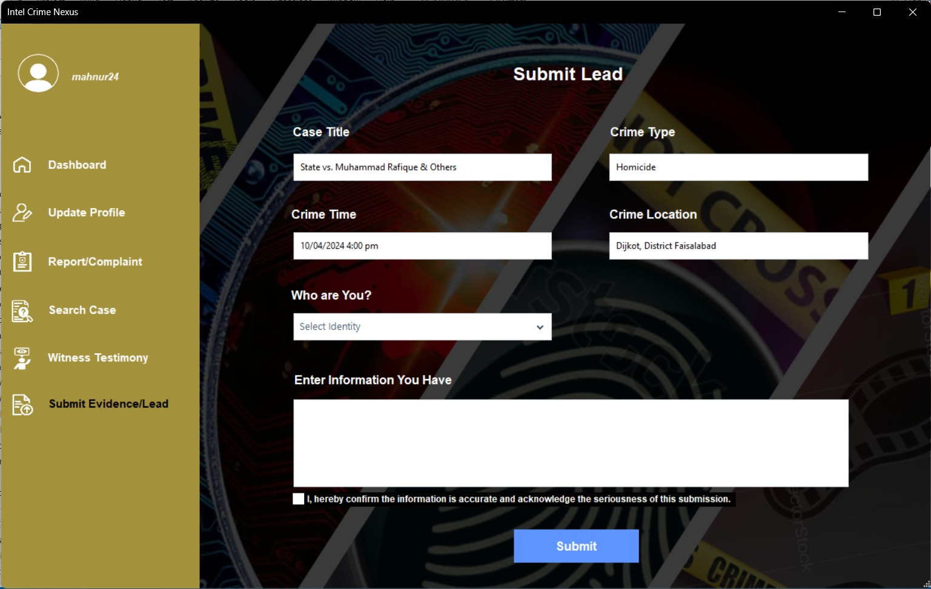

Submit Evidence by User:

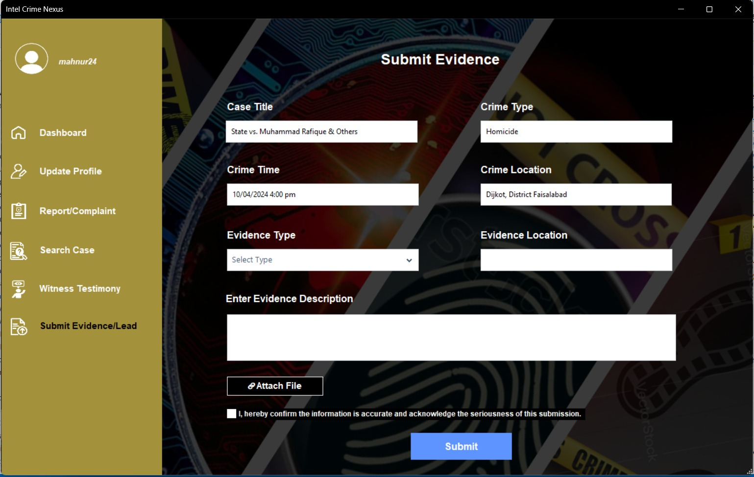

Detect Fake Reports:

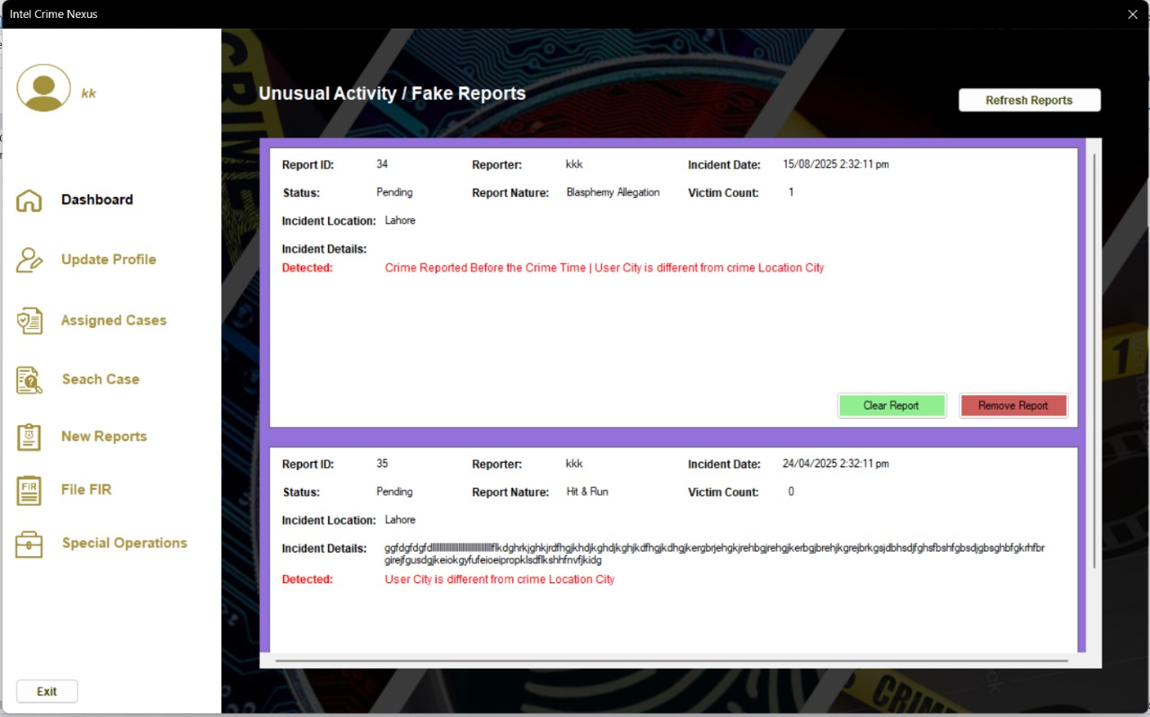

Check similar cases:

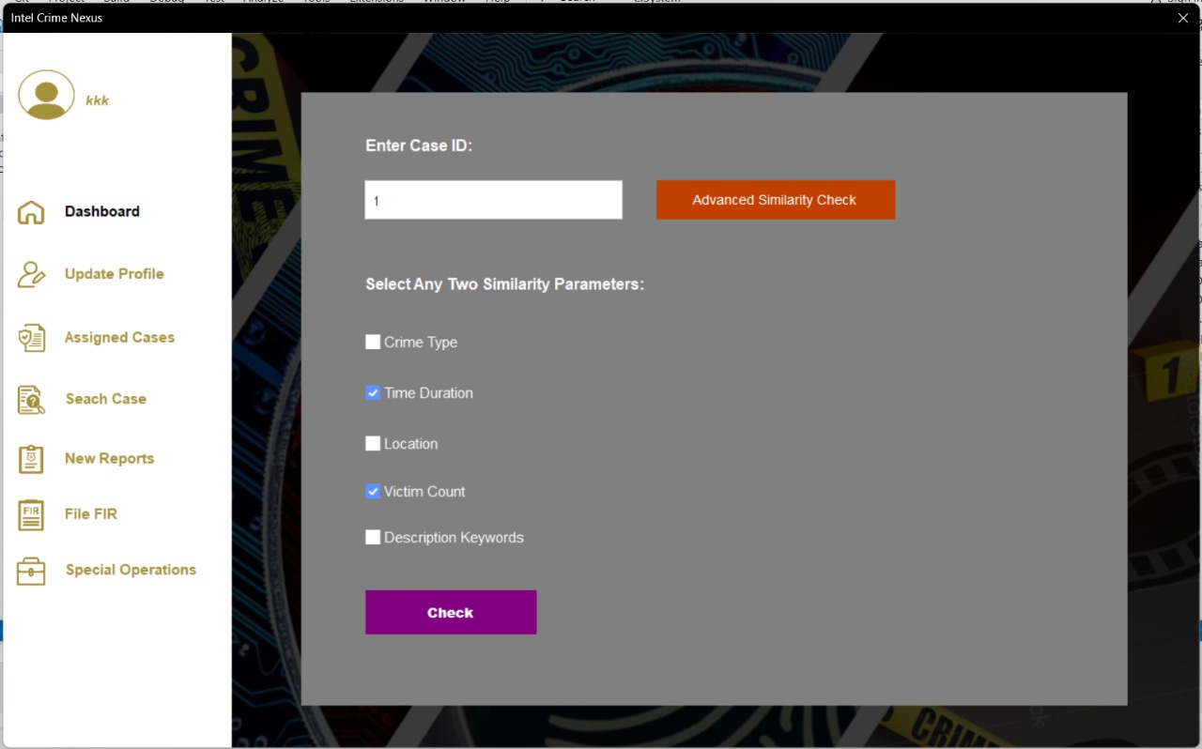

View Similar cases:

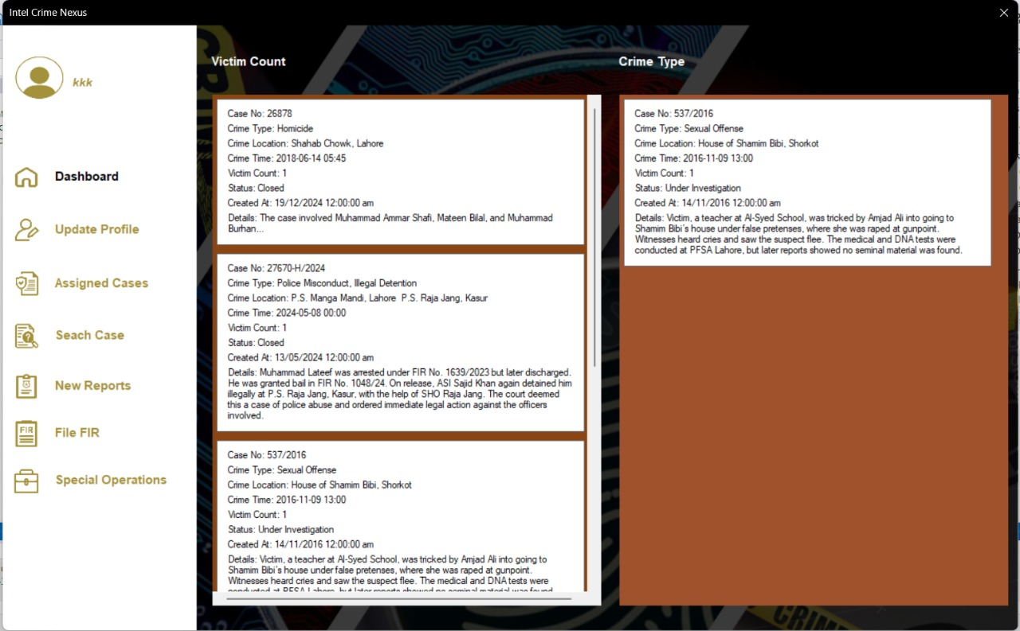

**Sprint Burn down Chart:**

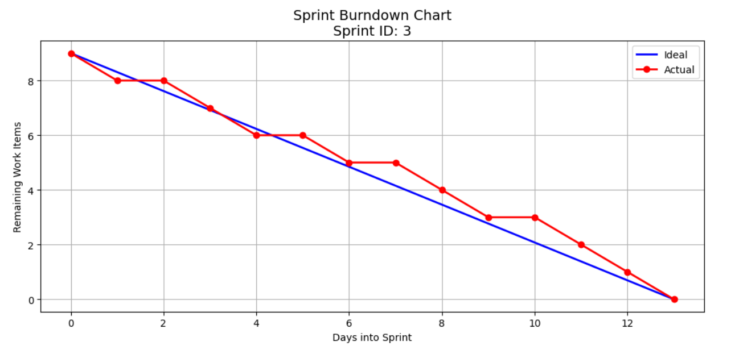

**Trello Board:**

**Sprint 1:**

Initial:

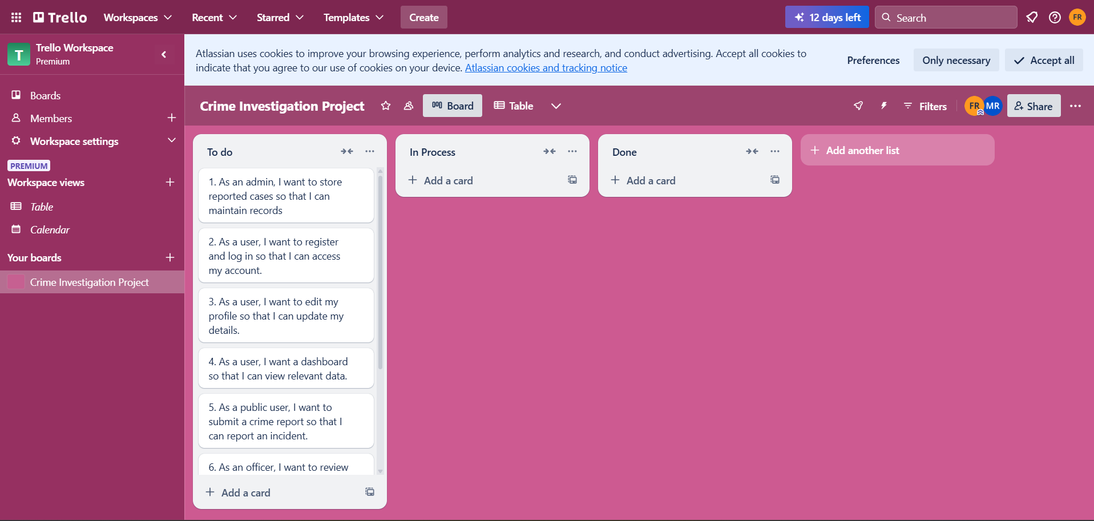

In Process:

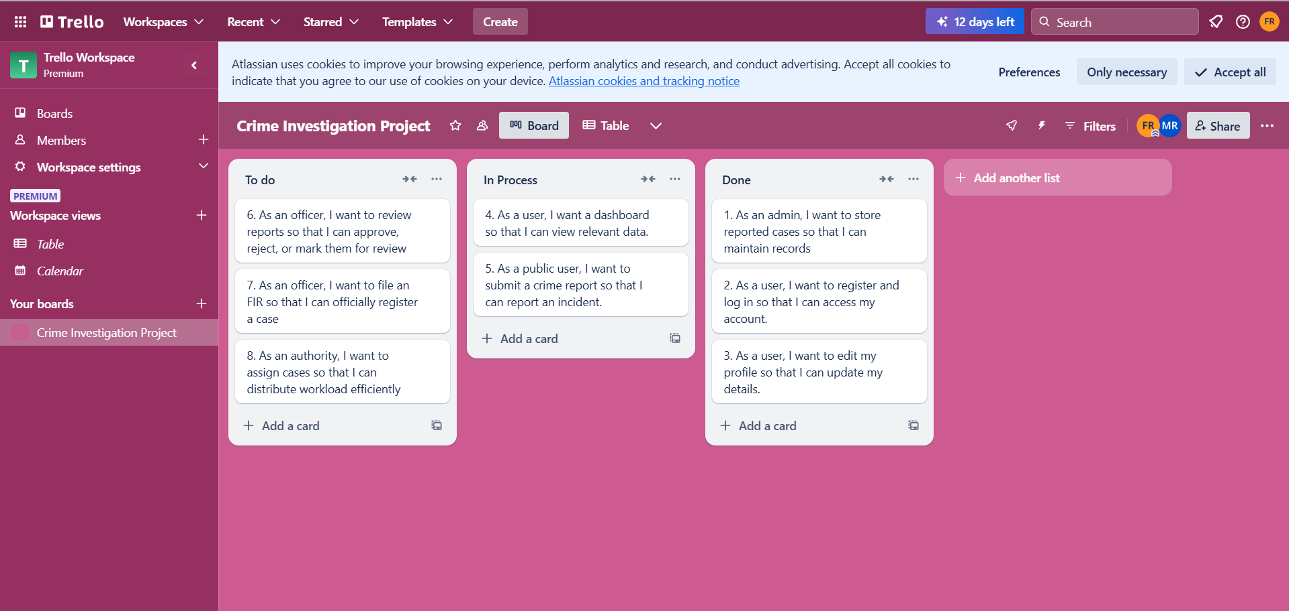

Final:

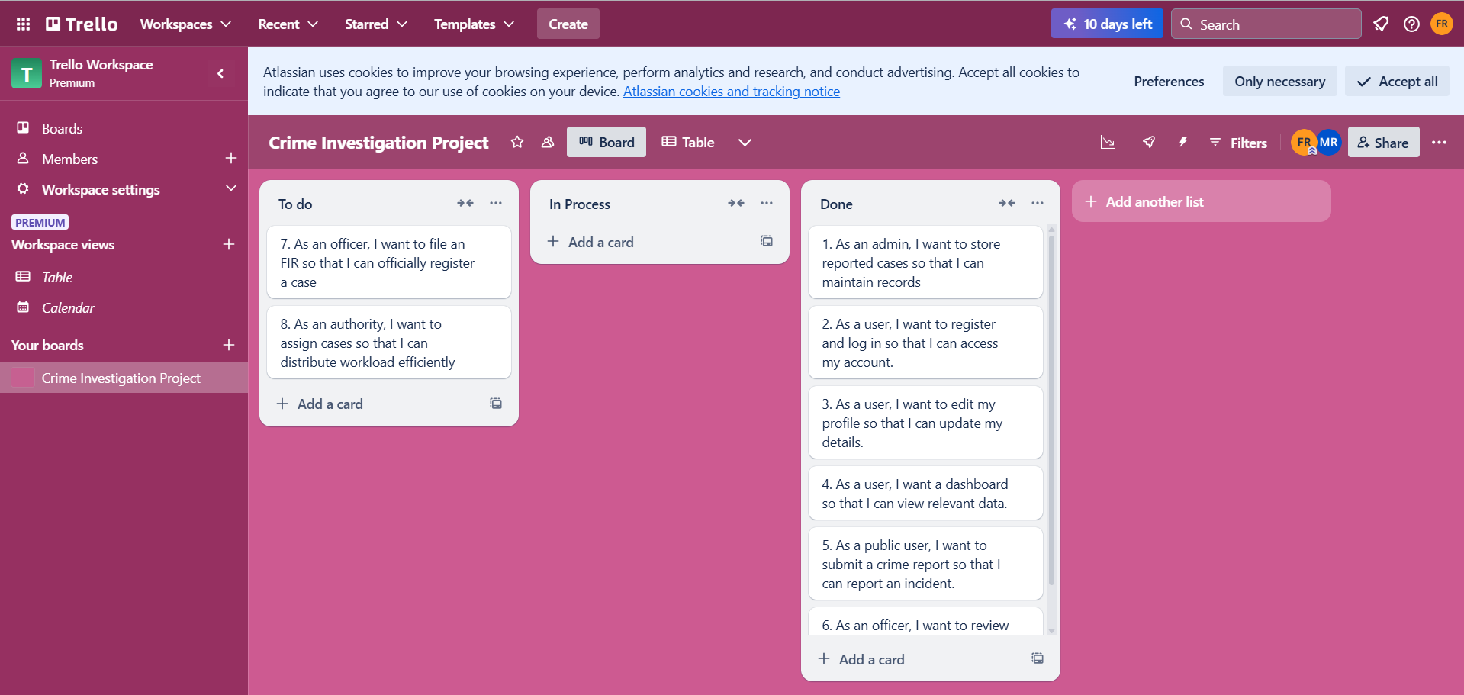

**Sprint 2:**

Initial:

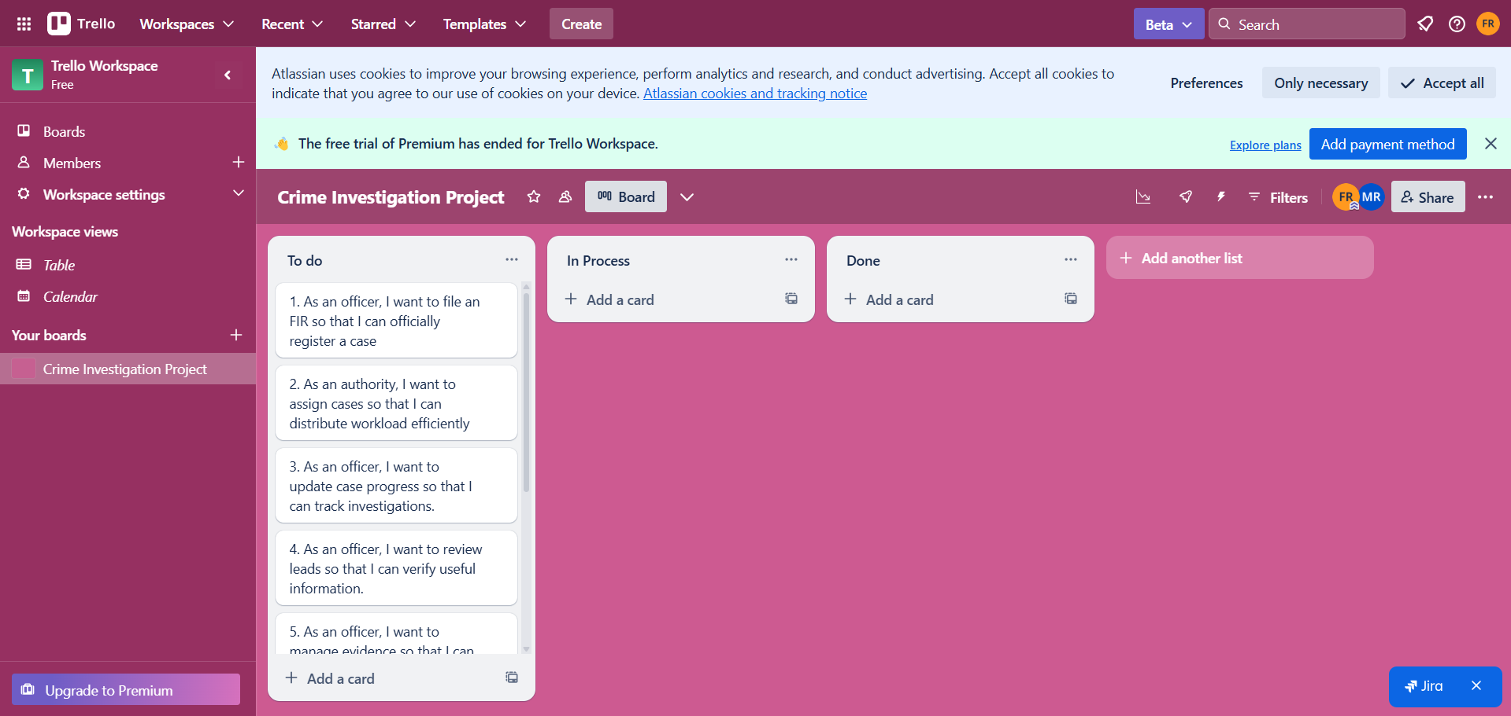

In Process:

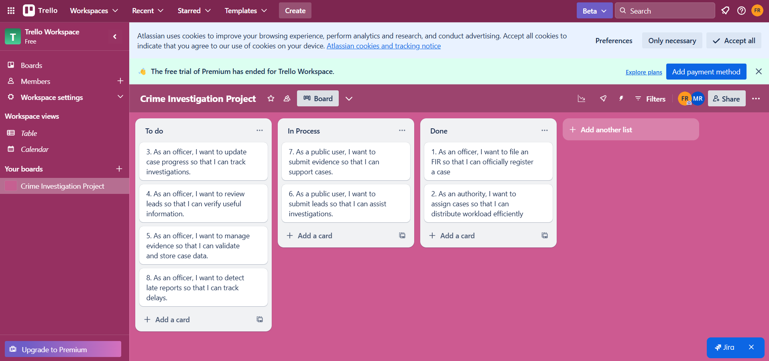

Final:

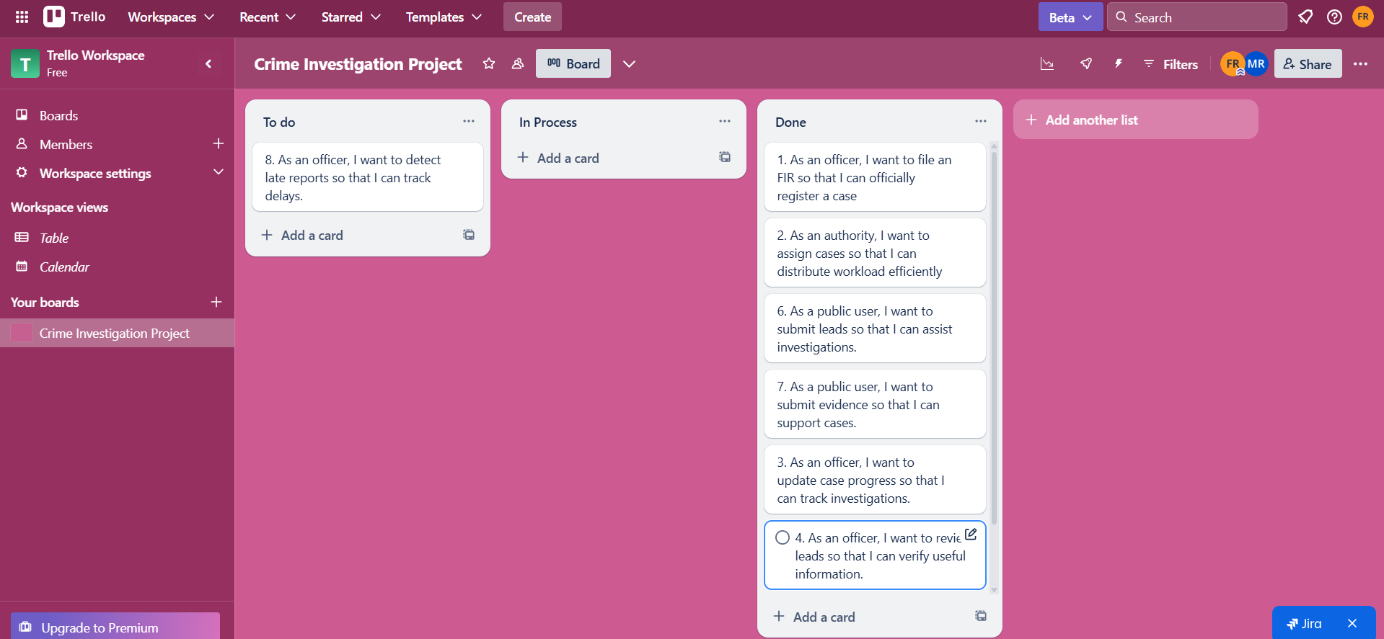

**Sprint 3:**

Initial:

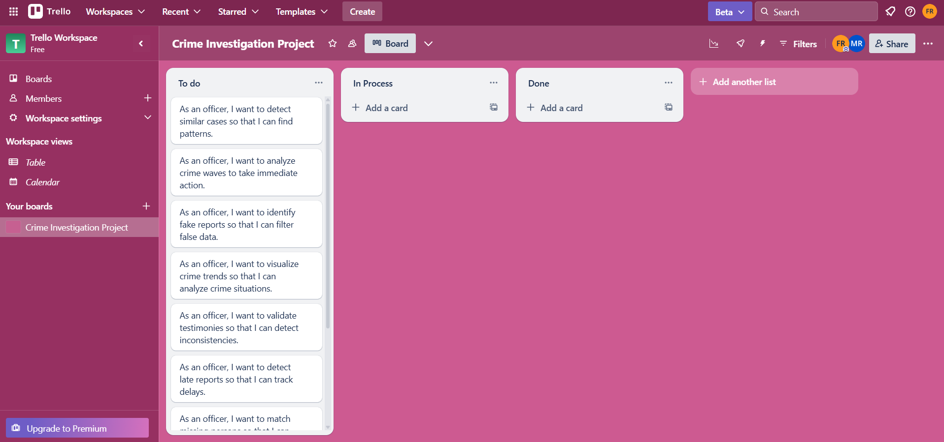

In Process:

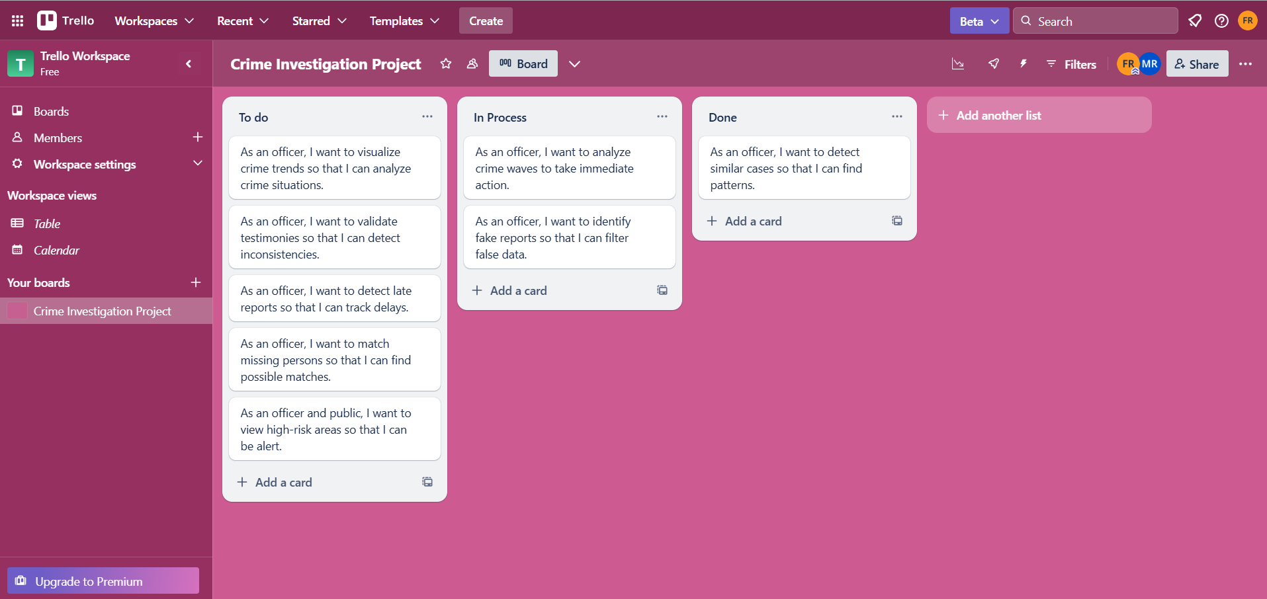

Done:  
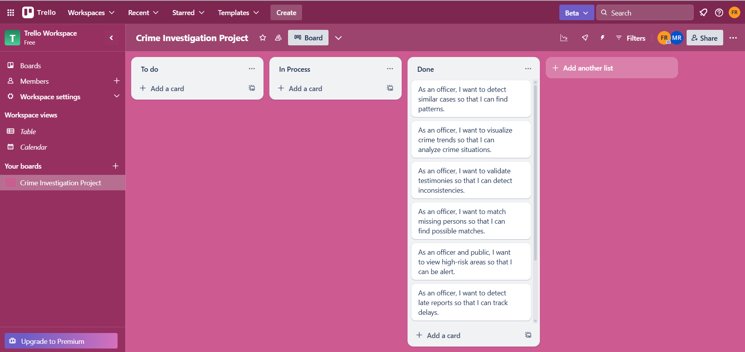

**Boundary Values Analysis Testing:**

**Work division:**

|  |  |  |  |
| --- | --- | --- | --- |
| **#** | **Role** | **Resource** | **Roll Number** |
| **1** | UI Designer | Aliza & Rabia | 23L-2524 & 23L-2560 |
| **2** | Backend Developer | Mahnoor & Fatima | 23L-2526 & 23L-2637 |
| **3** | Database Manager | Mahnoor & Fatima | 23L-2526 & 23L-2637 |
| **4** | Tester | Aliza & Rabia | 23L-2524 & 23L-2560 |
| **5** | Scrum Master | Fatima | 23L-2637 |
| **6** | Project Manager | Mahnoor | 23L-2516 |

**Lesson Learned:**

This project was honestly one of the most meaningful experiences we've had so far. Choosing such a deep and unique idea made the journey exciting — and at times, a little chaotic too. There were moments when tight deadlines had us questioning our life choices (and occasionally our sanity) for picking something so emotionally and technically complex! But despite the pressure, working together as a group made it all worth it. We laughed, stressed, learned, and grew — not just as students, but as thinkers who truly wanted to build something that matters. In the end, it wasn’t just a project; it felt like something personal — and we’re proud of it.